SystemC-Integrated Embedded C Simulation for a Multi-Sensor Data Acquisition System
1. Introduction
A multi-sensor data acquisition system is an embedded system that collects data from multiple sensors, processes the information, and displays the results in real time. In this project, an ESP32 microcontroller is used to interface with a DHT22 temperature and humidity sensor, an LDR sensor for light intensity, and a potentiometer acting as a simulated gas sensor. The system was designed and tested using the Wokwi simulation platform with Embedded C programming.
2. Objective
The objective of this project is to design and simulate a multi-sensor monitoring system capable of collecting environmental data from different sensors and displaying the readings on an LCD. The system also indicates normal and abnormal conditions using LEDs based on predefined threshold values. The project demonstrates real-time data acquisition, sensor interfacing, and embedded system programming concepts.
3. Components Used
Components | Components
ESP32 Development Board | Green LED
DHT22 Temperature & Humidity Sensor | Red LED
LDR (Light Dependent Resistor) Module | 220 Ω Resistors
Potentiometer (Simulated Gas Sensor) | Jumper Wires
16×2 I2C LCD Display | Wokwi Online Simulator

4. Working Principle
The ESP32 continuously reads data from the DHT22, LDR, and potentiometer. The collected sensor values are processed using Embedded C and displayed on the LCD and Serial Monitor. The program compares the sensor readings with predefined threshold values. If the temperature exceeds 40°C or the simulated gas value becomes high, the red LED is activated to indicate an alert condition. Otherwise, the green LED remains ON, indicating normal system operation. The process repeats continuously to provide real-time environmental monitoring.

Figure 1. Wokwi Circuit Design
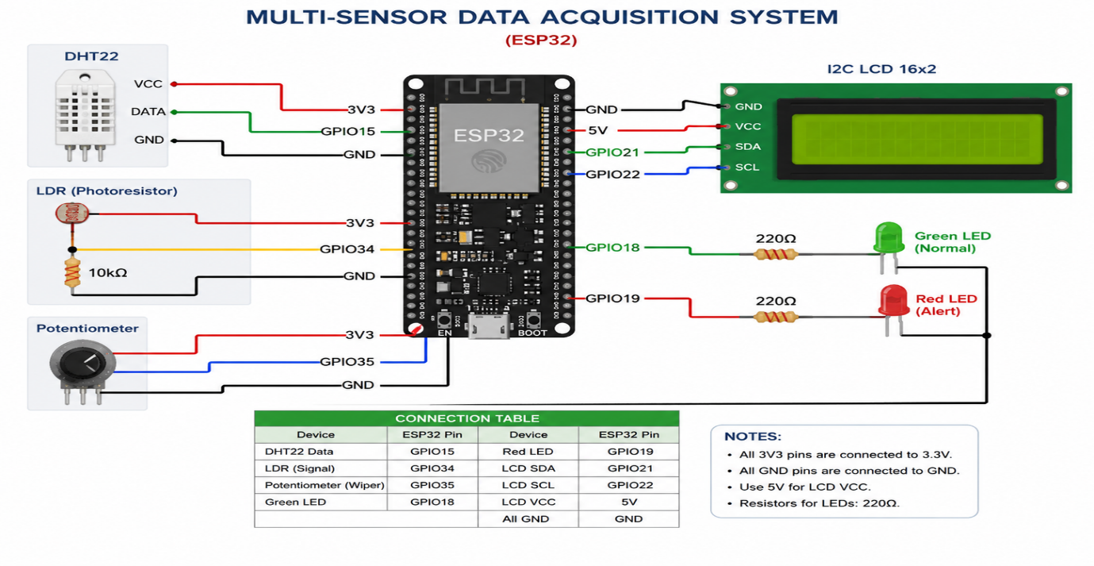

5. Simulation Results
The simulation was successfully executed in the Wokwi environment. All sensors responded correctly, and their values were displayed on the LCD in real time. The Serial Monitor also displayed the sensor readings for verification. During normal operating conditions, the green LED remained ON. When the temperature or simulated gas level exceeded the threshold, the red LED turned ON, confirming the correct operation of the alert mechanism.
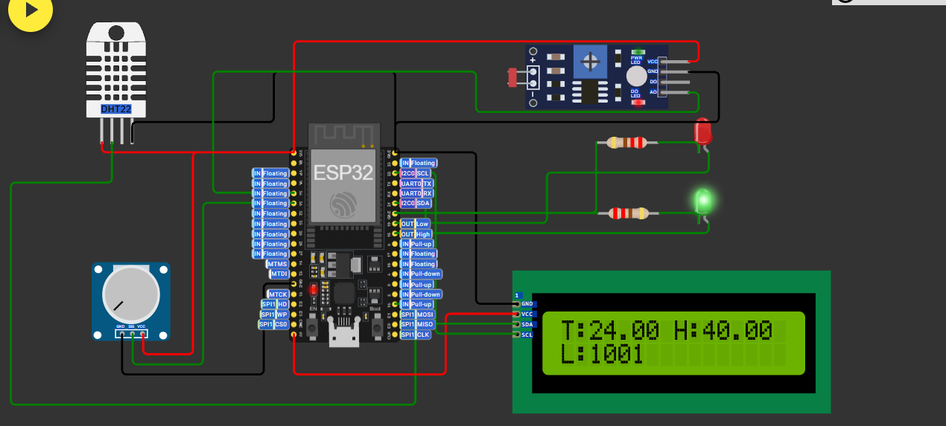

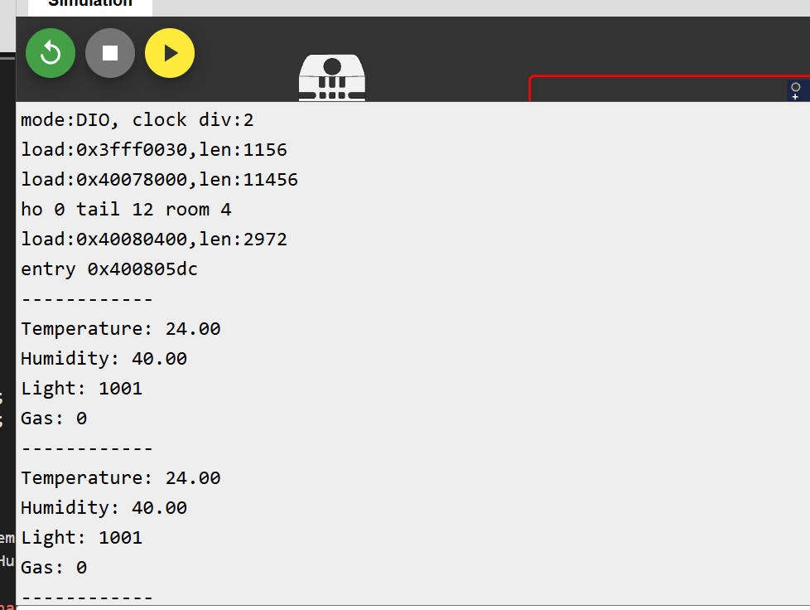
6. Conclusion
The SystemC-Integrated Embedded C Simulation for a Multi-Sensor Data Acquisition System was successfully implemented using the ESP32 in the Wokwi simulation platform. The system accurately monitored multiple environmental parameters, displayed the readings on an LCD, and generated alerts whenever threshold values were exceeded. The project demonstrated the practical implementation of Embedded C programming, sensor interfacing, and real-time monitoring. This system can be extended with cloud connectivity and IoT technologies for remote monitoring and data logging.
Code
#include <Wire.h>
#include <LiquidCrystal_I2C.h>
#include <DHT.h>
#define DHTPIN 15
#define DHTTYPE DHT22
#define LDR_PIN 34
#define GAS_PIN 35
#define GREEN_LED 18
#define RED_LED 19
DHT dht(DHTPIN, DHTTYPE);
LiquidCrystal_I2C lcd(0x27,16,2);
void setup() {
Serial.begin(115200);
dht.begin();
lcd.init();
lcd.backlight();
pinMode(GREEN_LED, OUTPUT);
pinMode(RED_LED, OUTPUT);
}
void loop() {
float temp = dht.readTemperature();
float hum = dht.readHumidity();
int lightValue = analogRead(LDR_PIN);
int gasValue = analogRead(GAS_PIN);
Serial.println("------------"); Serial.print("Temperature: "); Serial.println(temp);
Serial.print("Humidity: "); Serial.println(hum);
Serial.print("Light: "); Serial.println(lightValue); Serial.print("Gas: ");
Serial.println(gasValue); lcd.clear();
lcd.setCursor(0,0); lcd.print("T:");
lcd.print(temp); lcd.print(" H:");
lcd.print(hum); lcd.setCursor(0,1); lcd.print("L:"); lcd.print(lightValue);
if(temp>40 || gasValue>2000)
{
digitalWrite(RED_LED,HIGH);
digitalWrite(GREEN_LED,LOW);
}
else
{
digitalWrite(RED_LED,LOW);
digitalWrite(GREEN_LED,HIGH);
}
delay(2000);
}

